

Data Flow Diagram

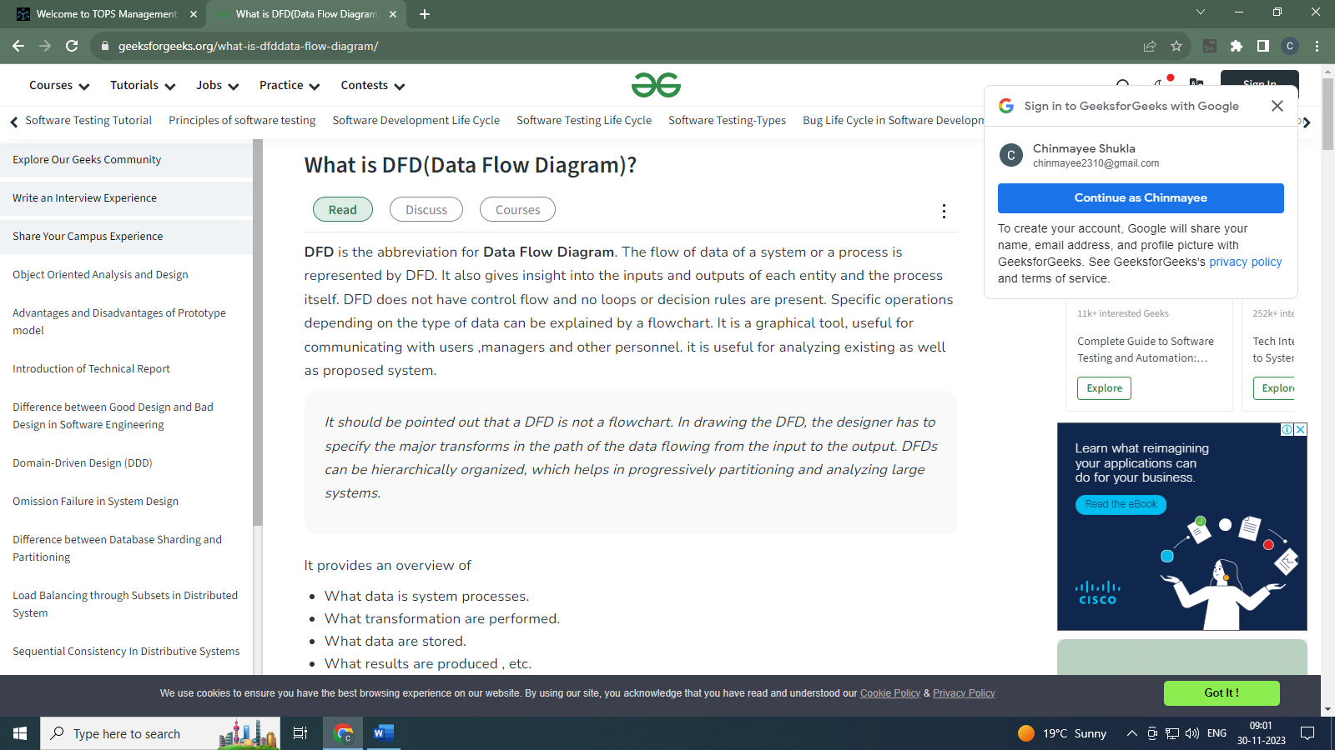

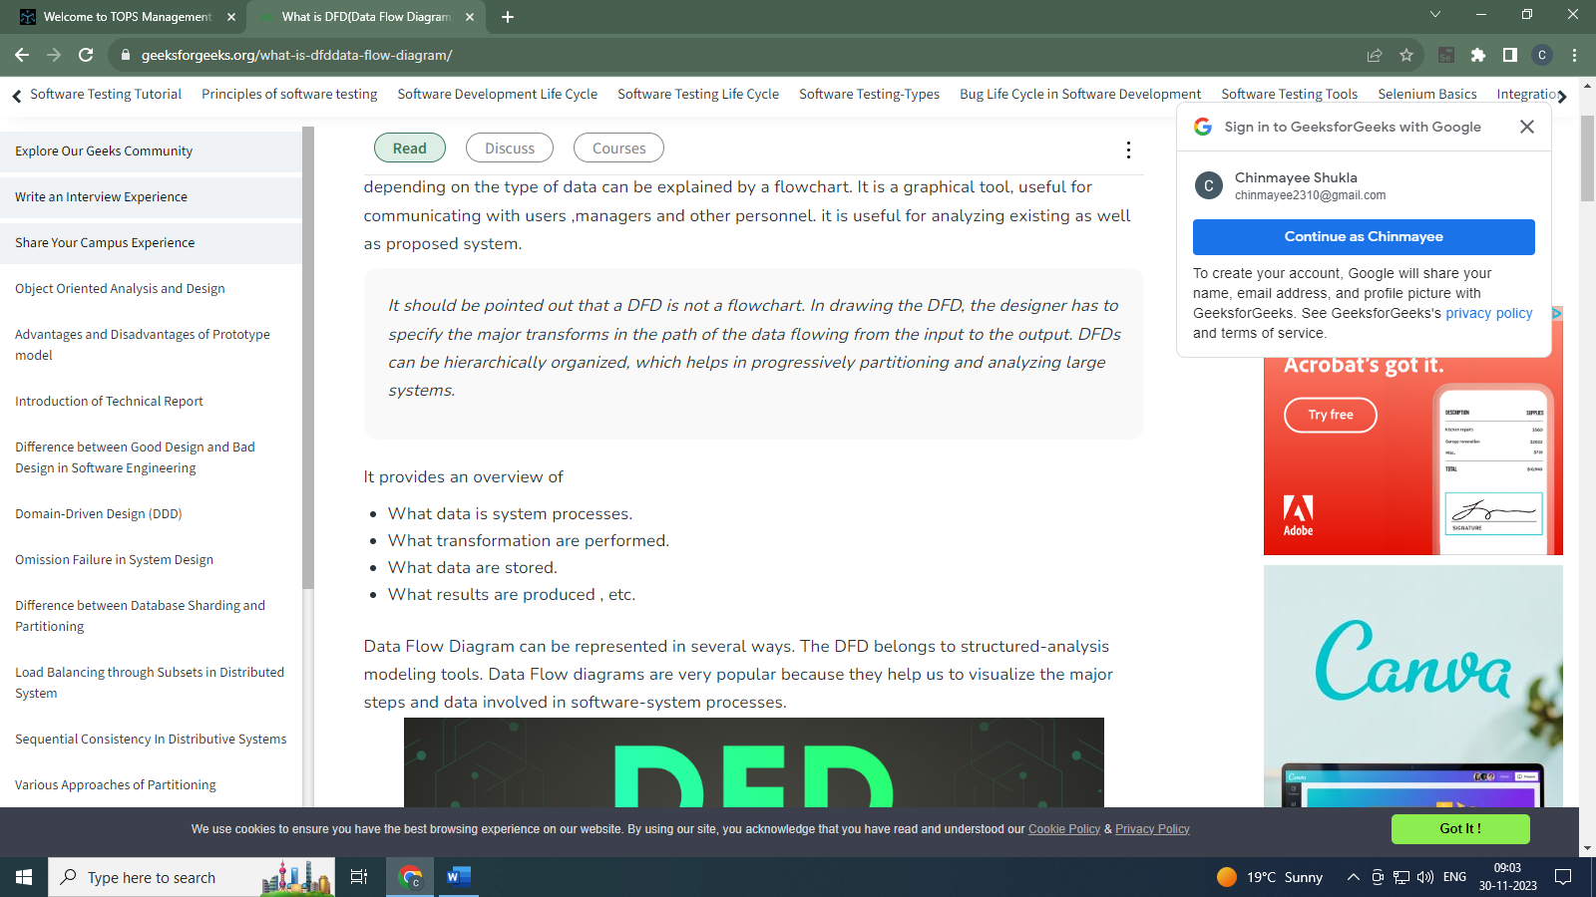

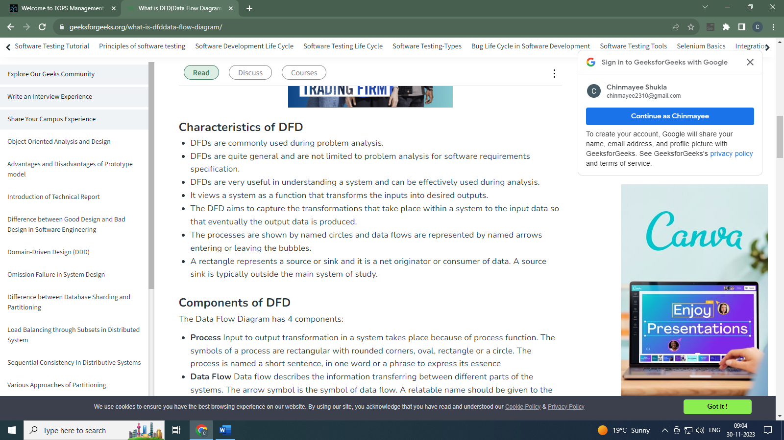

**Components of DFD :**

**Process**

**Data Flow**

**Data Store**

**External Entity**

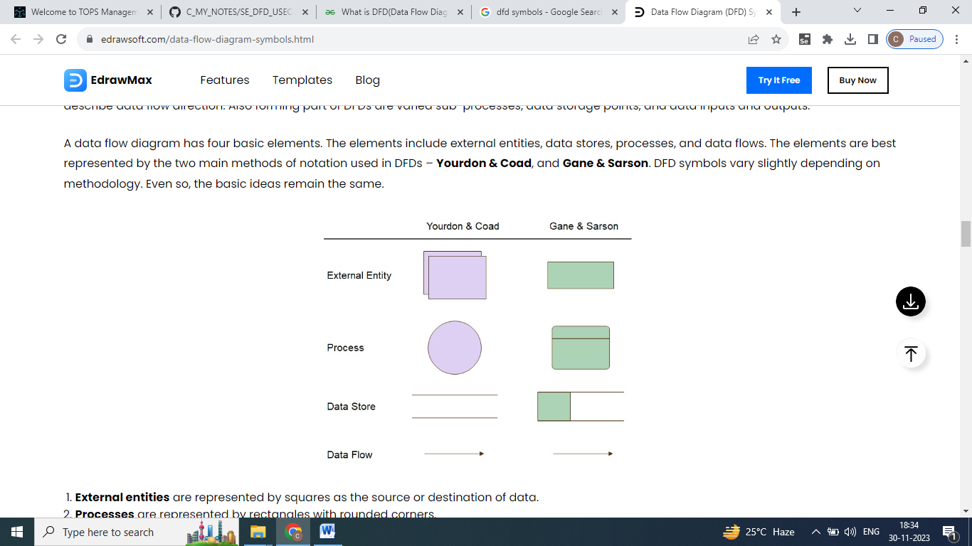

|  |  |
| --- | --- |
|  |  |

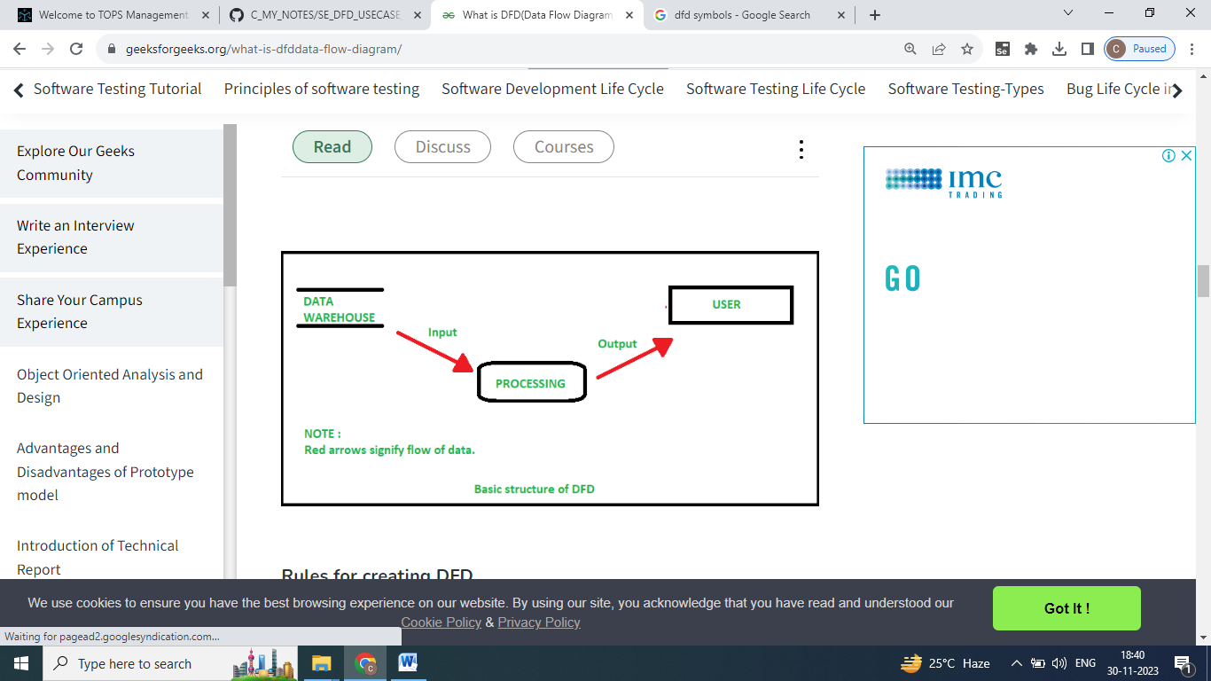

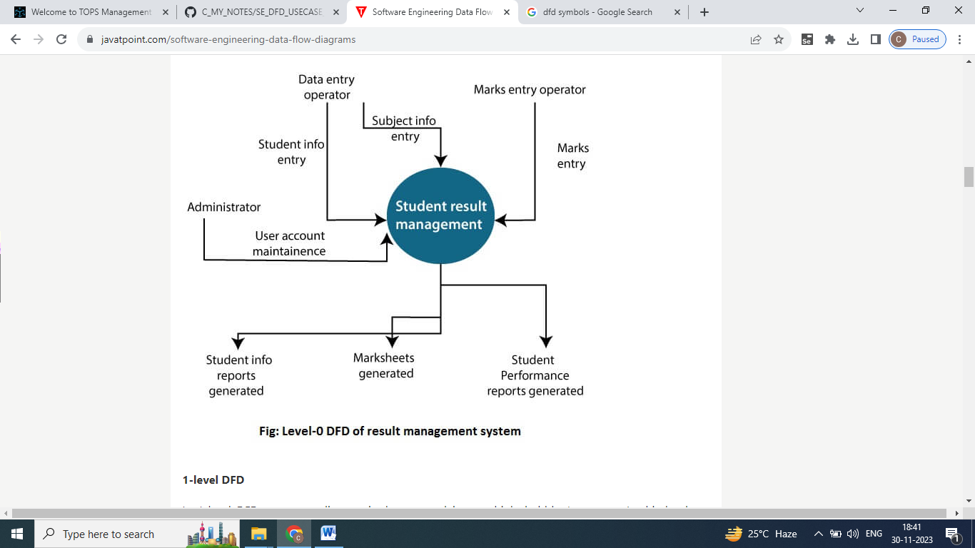

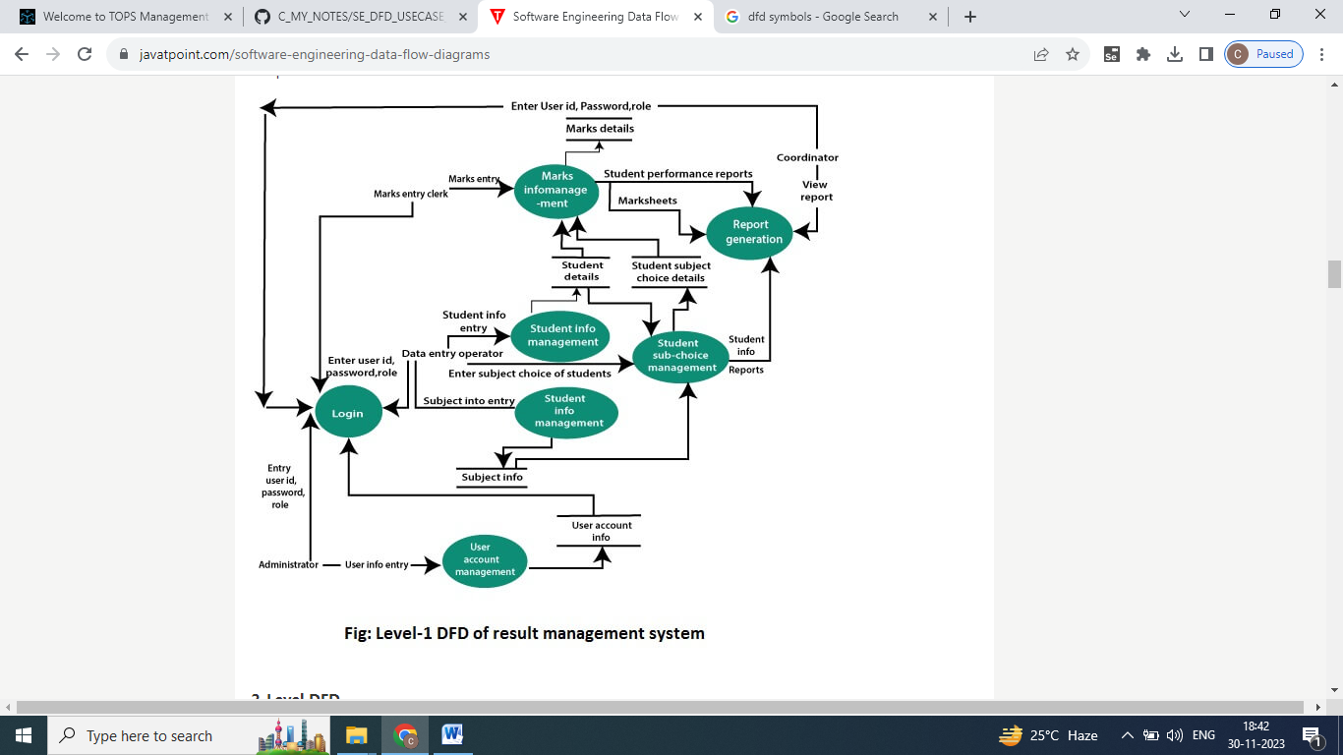

|  |  |
| --- | --- |
|  |  |
|  |  |

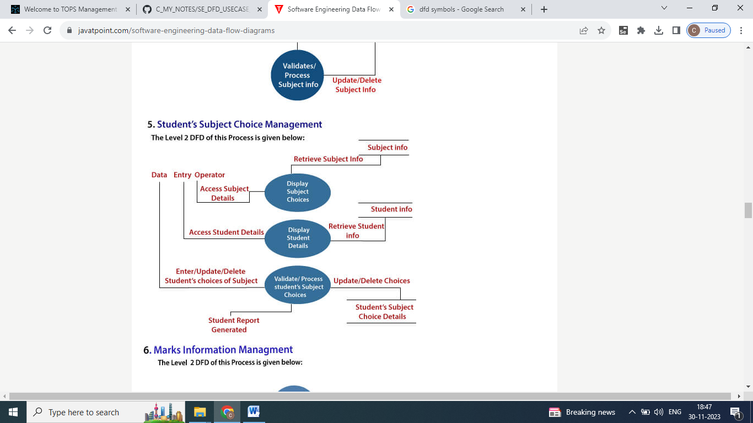

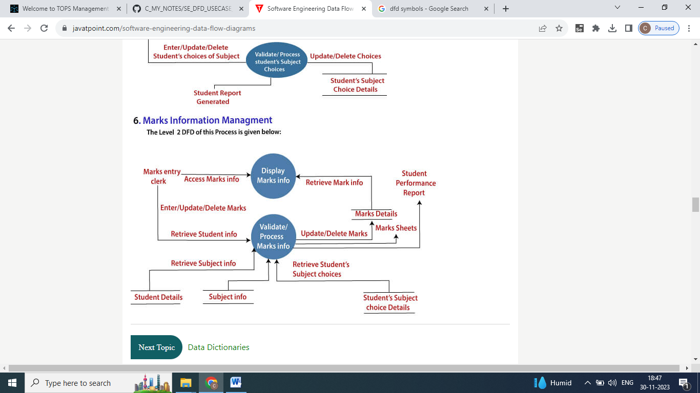

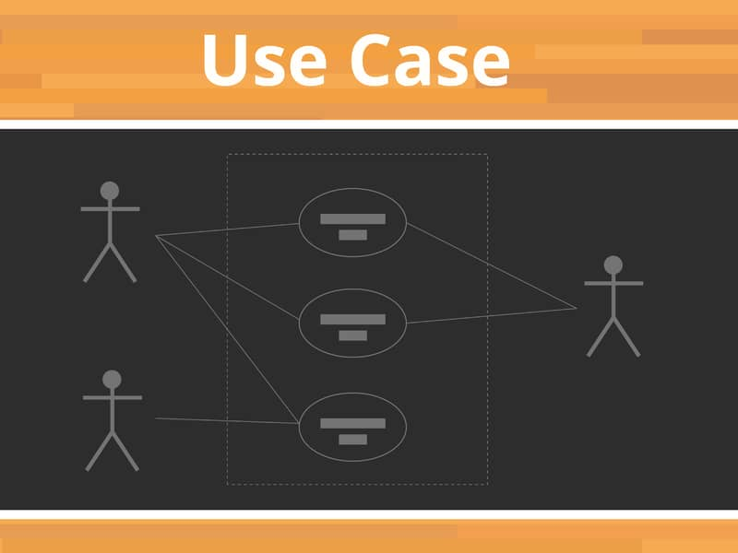

A use case is a written description of how users will perform tasks on your website. It outlines, from a user's point of view, a system's behavior as it responds to a request. Each use case is represented as a sequence of simple steps, beginning with a user's goal and ending when that goal is fulfilled.

**Components of Basic Model**

There are various components of the basic model:

1. Actor
2. Use Case
3. Associations

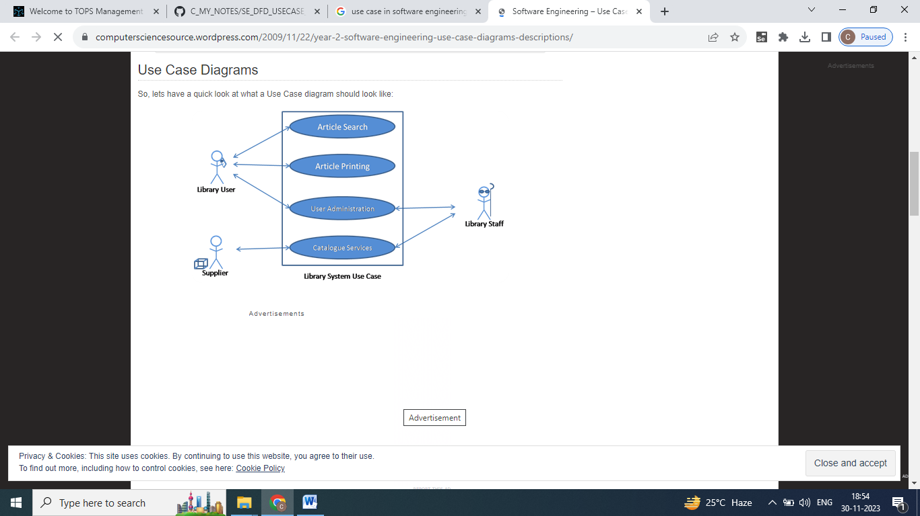

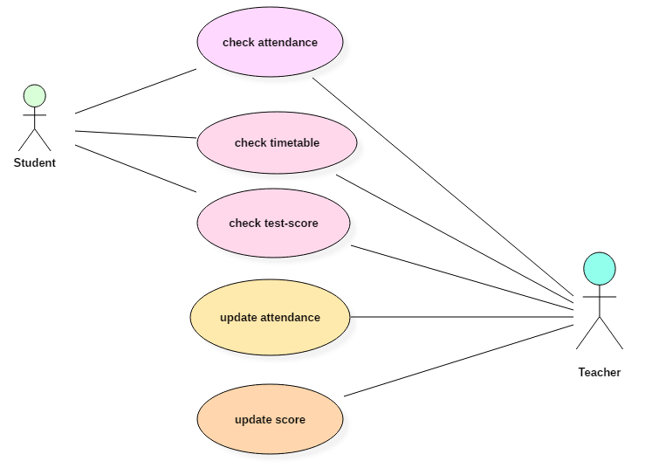

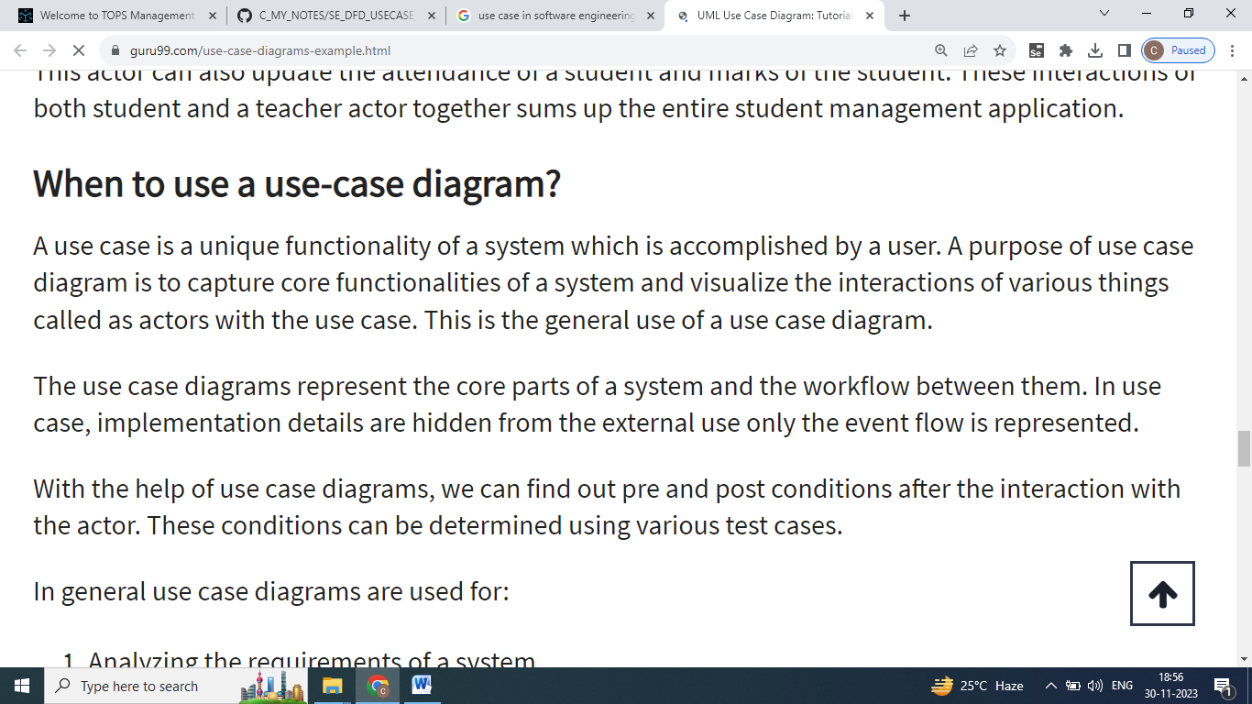

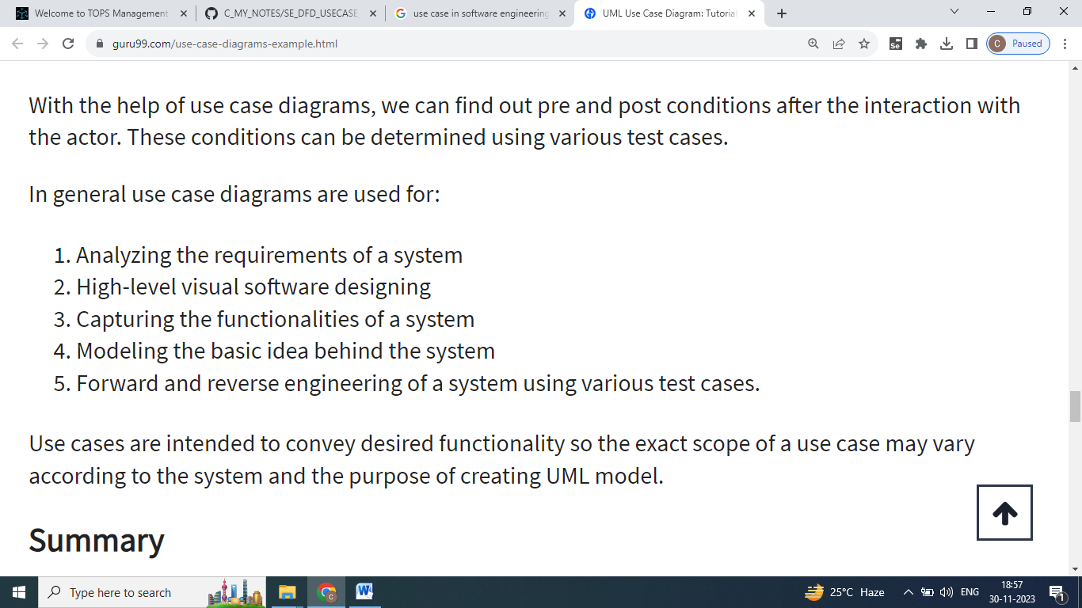

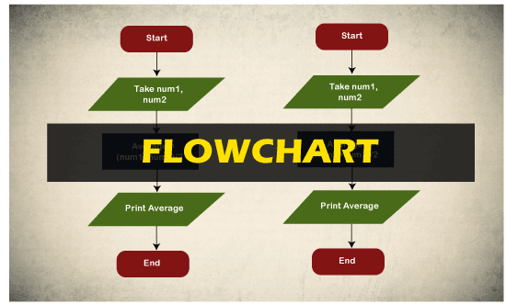

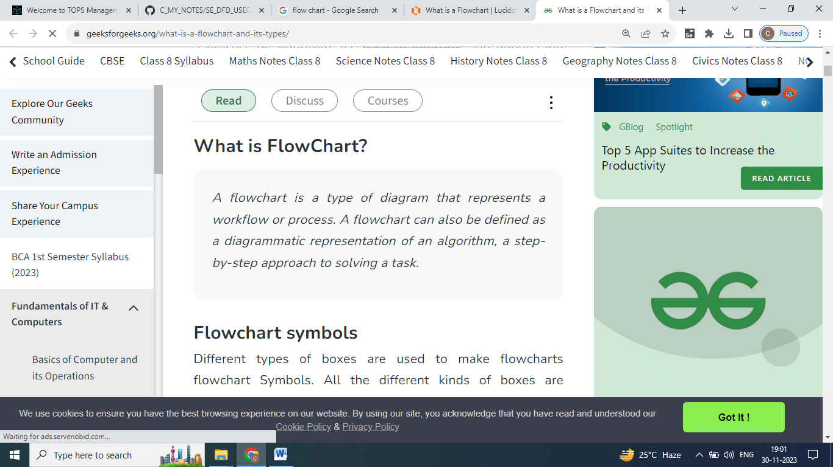

* A flowchart (or flow chart) is a diagram that shows the steps in a process.
* Flowcharts are often used for visualizing the sequence of actions or information needed for training, documenting, planning, and decision-making.
* They often use symbols, shapes, and arrows to illustrate how one step leads to another.

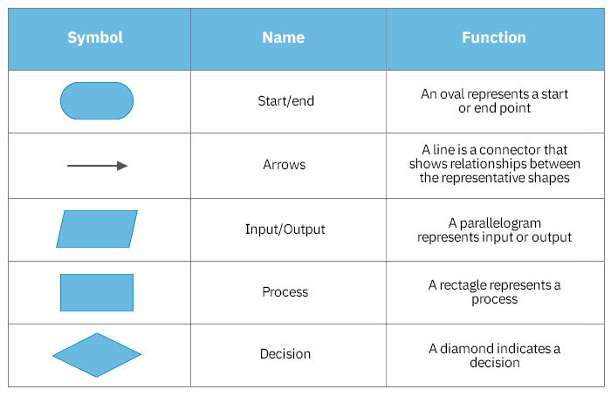

|  |  |
| --- | --- |
| Flowchart Tutorial (with Symbols, Guide and Examples) | What is A Flowchart - A Complete Guide | EdrawMax Online |

